Nature meets culture in Sylvia Safdie’s art
Kate Taylor
Published January 31, 2026

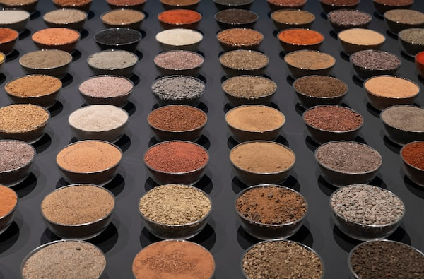

Sylvia Safdie has collected soil samples since 1977. Earth II brings together 500 of those samples, from places around the world.Photo: NGC/Artwork Collection of the artist Sylvia Safdie.
Early in her career, Montreal artist Sylvia Safdie noticed that her photographs of places failed to preserve atmosphere or memory. So in the Sinai Desert in 1977, she bent down and gathered up some soil because it seemed to summarize the place. She then began collecting soil samples from around the world, with contributions from friends and family.
Almost 50 years later, 500 of them are displayed in small glass bowls at the National Gallery of Canada, an earthy United Nations arranged in tidy rows on a low black platform. The beautiful array, resembling the wares of some well-travelled spice merchant, offers the most remarkable range of colours and textures, from flinty chips of green and grey to yellow and red sands, along with a few bowls filled with plain old dirt.
That installation is the striking introduction to Sylvia Safdie: Terra, a small retrospective arranged in two rooms (in the building that, coincidentally, the artist’s brother, architect Moshe Safdie, designed in the 1980s). In the second are metal shelves of her collections that reveal more of her approach, and how she works through subtle modifications of natural and found materials.

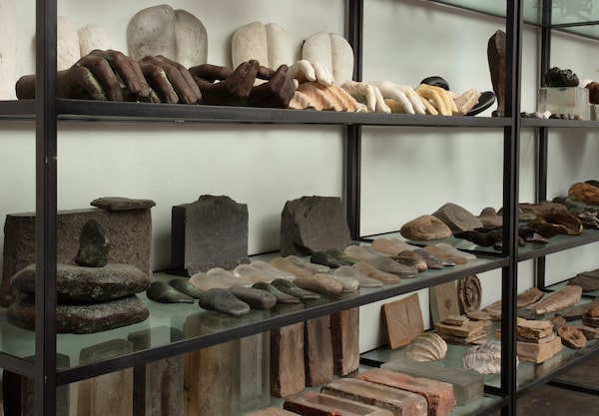

Pieces from Safdie's collection, dating between 1986 and 2025, include found objects, natural materials and small sculptures.Photo: NGC/Artwork Collection of the artist Sylvia Safdie
Titled Assemblages, and dating from 1986 to the present, the shelves hold found objects, such as a collection of bricks and natural specimens including rocks, pebbles, branches and seed pods. These items sit alongside glass, bronze and concrete sculptures of hands, fruit and the seed pods themselves.
Also on display is a series of paintings begun in 2002, for which Safdie marked Mylar sheets with earth and graphite, experimenting with how little it took to suggest a human figure or face. This leads to work that considers our relationship with representation, the magical way a handprint in clay reproduces human form, for example, or how the slightest mark on a flat piece of paper reads as three-dimensional space.

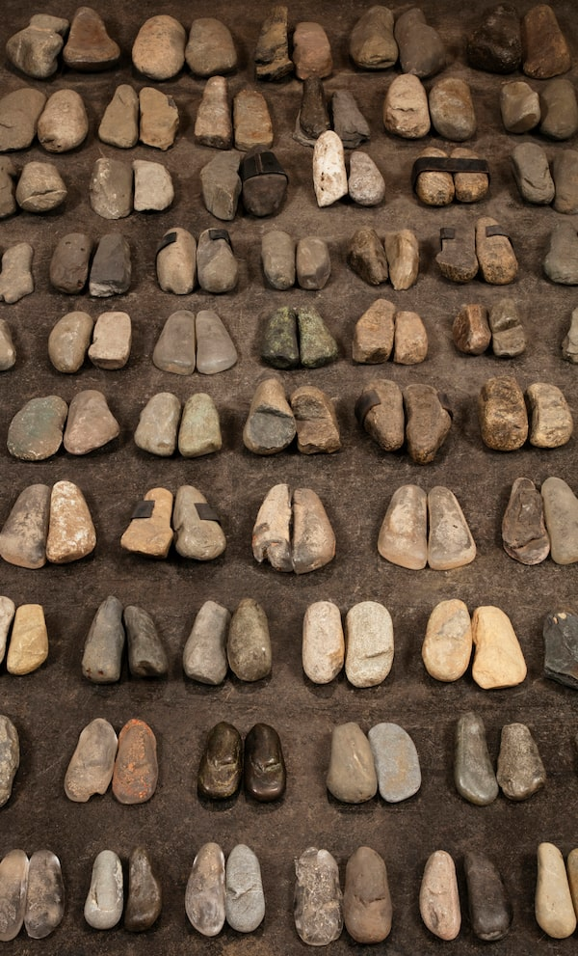

In Feet, shoe-shaped stones sit alongside sculptures reproducing their shapes.Photo: NGC/Artwork Collection of the artist Sylvia Safdie
Exhibiting great respect for her materials, she reveals small gestures as big art. Through a decades-long practice of collecting and sculpting, Safdie has created Feet, a series of about 70 pairs of oval, shoe-shaped stones and glass and bronze sculptures reproducing that shape. Heads produces the same effect with big round stones and the occasional sculpted addition. It’s hard to tell in these pieces where the stones stop and the modifications begin, as Safdie considers the intersection of nature and culture.
The works are deeply meditative, an approach pursued further in video works. Luna No. 1 and Luna No. 2, from 2024, feature positive and negative images of clouds passing over a full moon. Shifting No. 1, from 2018, is a horizontal strip of video shot the year before at Tanzania’s Lake Manyara, where Safdie recorded a Maasai herdsman grazing his cattle on the mud flats exposed by shifting waters.
The scene is observed from a far distance with high-contrast distortions: The moving cattle are mysterious liquid shapes while the herdsman bobs across the scene like a float. These creatures seem to tread lightly on the Earth, as though in sync with its rhythms, as Safdie reflects again on our relationship with nature and place.
We live in a politically divided time, in which art is often harnessed to social and political agendas with little regard for its formal properties. It’s refreshing to spend time with work that takes its materials as its themes and, not coincidentally, never neglects the aesthetic. Safdie encourages slow looking instead of quick thinking.
Sylvia Safdie: Terra continues at the National Gallery in Ottawa to Oct. 25.

